24ADI204 - Data Science & Visualization
Team Number: 18
Week-04 Report
Exploratory Data Analysis (EDA) - Price Drivers
Project: House Price Analysis and Dashboard

Objective
The objective of Week 4 is to perform Exploratory Data Analysis on the cleaned housing dataset to understand how house prices are distributed and which factors influence them. The main goal is to study the price distribution, the effect of living area and bedrooms, the relationship between features and the price differences between cities.

Dataset Overview
The cleaned dataset (housing_cleaned.csv) contains 4,600 records and 18 attributes with no missing values and no duplicates. The analysis uses price, bedrooms, sqft_living, the numerical features for correlation, and city for location-wise comparison.
GITHUB REPOSITORY LINK:
https://github.com/wahith628-cmyk/Housing-
COLAB NOTEBOOK LINK:
https://colab.research.google.com/drive/1KAtVlM3go3ssdov3AtYui318LcVl_YK9
DATASET LINK (KAGGLE):
https://www.kaggle.com/datasets/ananthaselvane/housing-dataset
Metric | Value
Total Records | 4,600
Average Price | 550,355
Median Price | 462,000
Strongest Correlation with Price | sqft_living (0.42)
Costliest City (average) | Medina (about 2.05M)

Code screenshot (Load cleaned data):
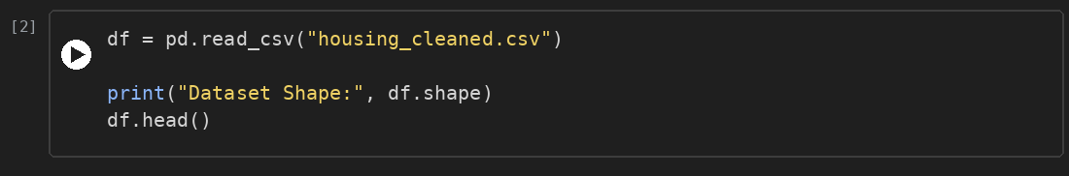

Univariate Analysis

House Price Distribution
The price distribution is strongly right-skewed. Most houses are priced below about 1 million, while a few very expensive houses stretch the tail up to 26.6 million. The average price is therefore higher than the median.
Code screenshot:
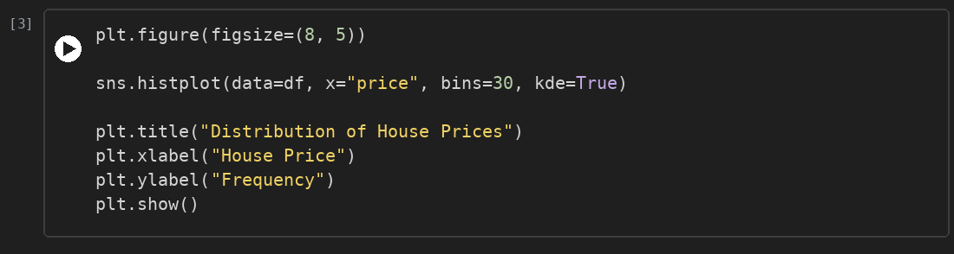
Output screenshot:
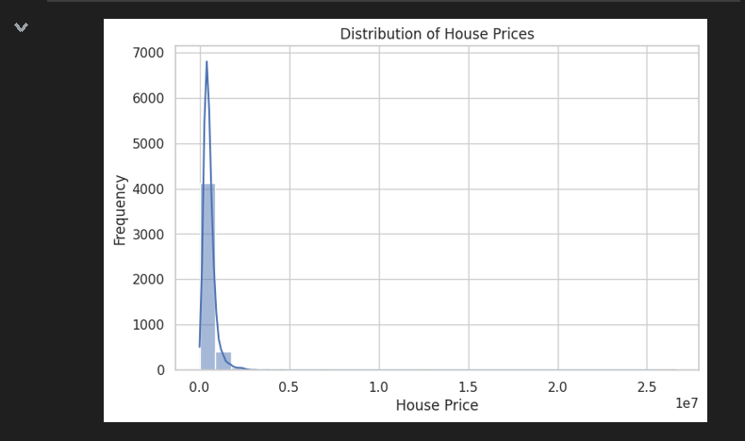

Bivariate Analysis

Living Area vs Price
Price increases as living area increases, showing a positive trend. Two extreme prices (about 26.6M and 12.9M) and one large house with a price near 0 do not follow the pattern and are treated as anomalies.
Code screenshot:
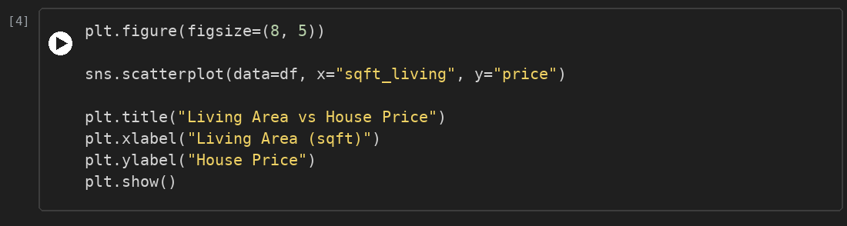
Output screenshot:
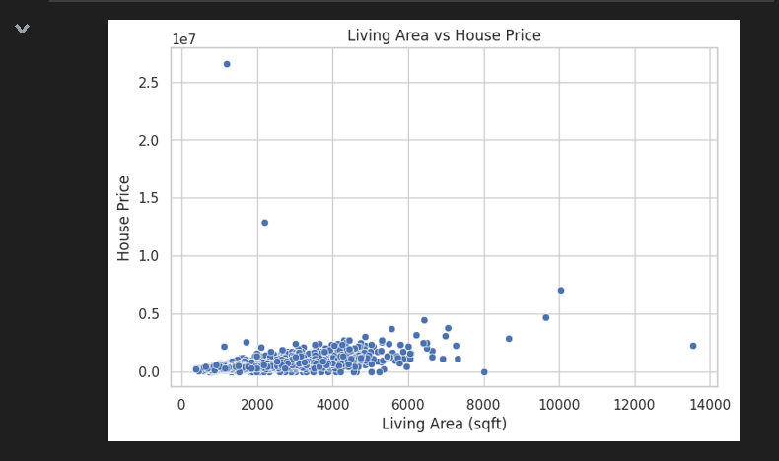

Bedrooms vs Price
The median price rises slowly with the number of bedrooms up to eight, but the price ranges overlap heavily. Bedrooms alone are therefore a weak indicator of price. A house with zero bedrooms and a high price looks like a data entry error.
Code screenshot:
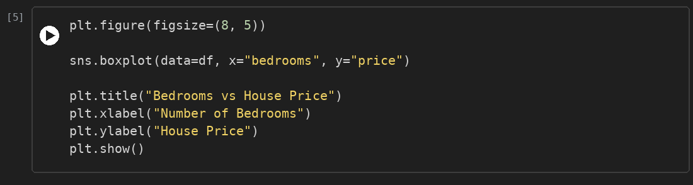
Output screenshot:
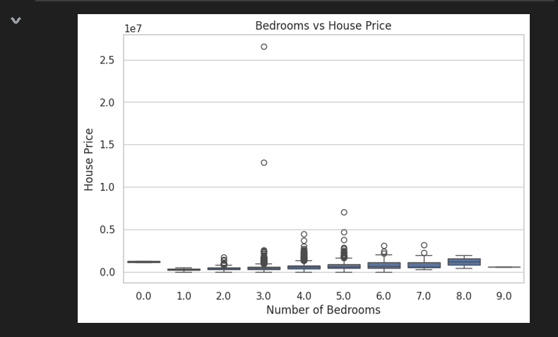

Correlation Matrix
sqft_living has the strongest relationship with price (0.42), followed by sqft_above (0.36) and bathrooms (0.32). sqft_lot, condition and yr_built have almost no relationship with price. The area features are strongly related to each other: sqft_living and sqft_above (0.86), sqft_living and bathrooms (0.75).
Code screenshot:
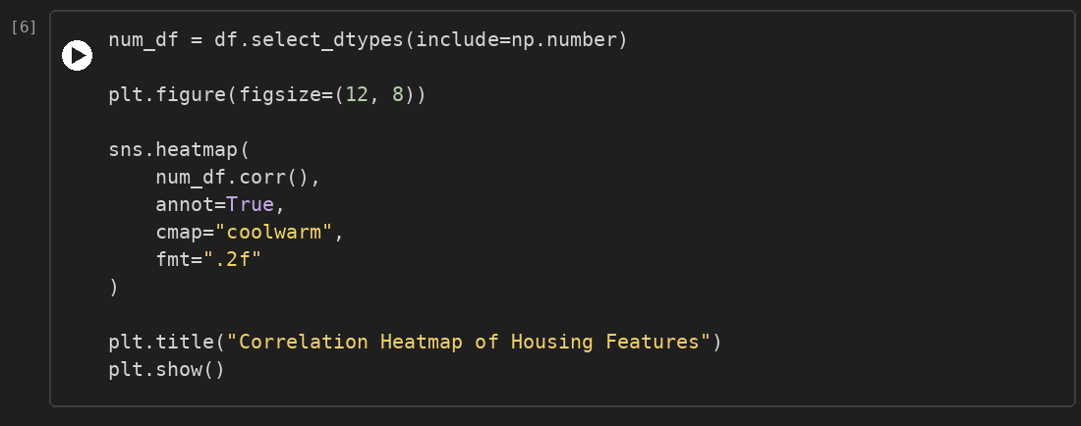
Output screenshot:
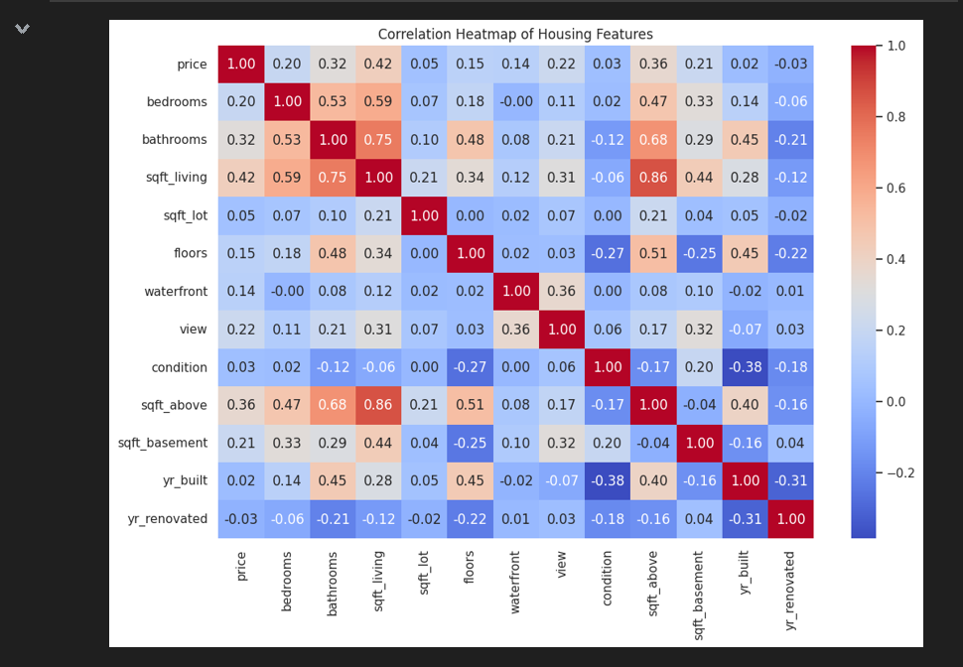

Average Price by City
Location has a large effect on price. Medina has the highest average price (about 2.05 million), followed by Clyde Hill (about 1.3 million) and Mercer Island (about 1.1 million). Even the tenth city, Redmond, averages about 0.66 million.
Code screenshot:
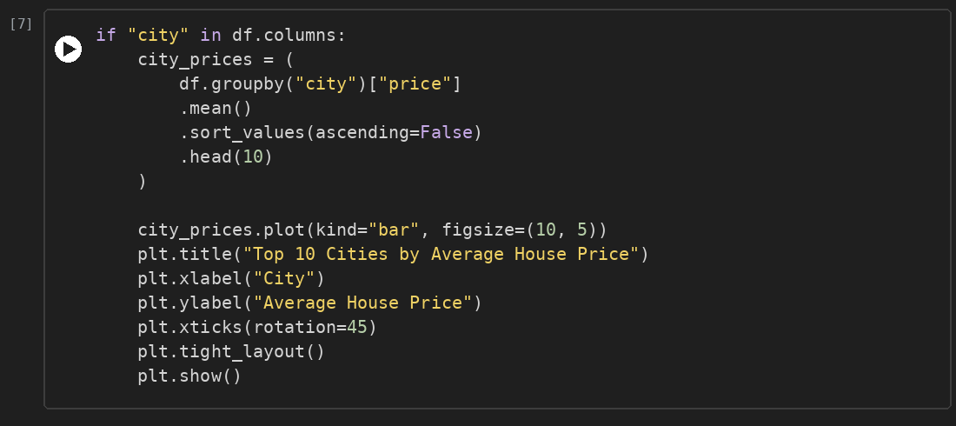
Output screenshot:
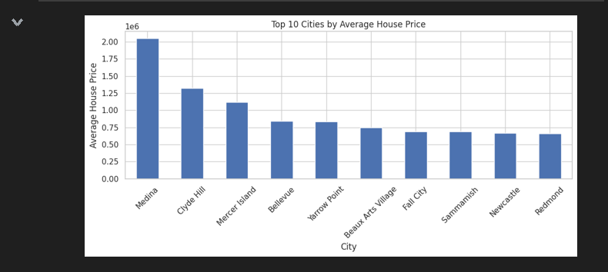

Statistical Insights
The price column has a mean of 550,355, a median of 462,000 and a standard deviation of 561,562, which shows a very high spread. The minimum price is 0 and the maximum is 26,590,000, so invalid and extreme prices must be treated before the final dashboard. The median living area is 1,970 sqft.
Code screenshot:
Output screenshot:
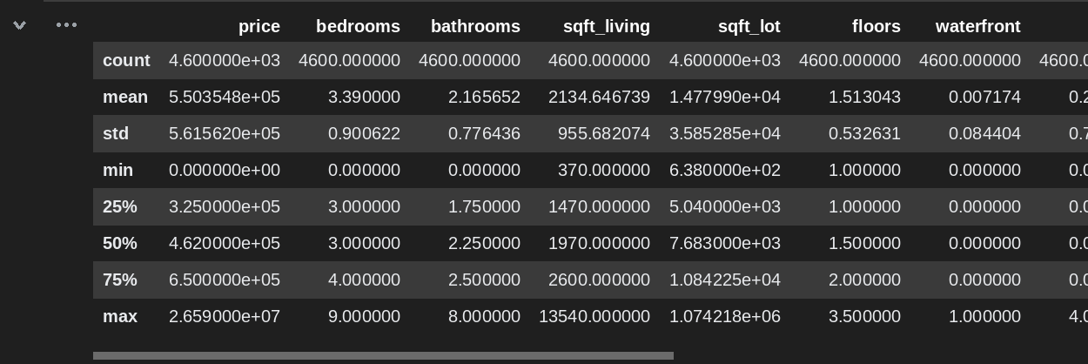

Key Findings
- House prices are right-skewed, with the mean (550K) above the median (462K).
- Living area is the strongest numerical factor affecting price (correlation 0.42).
- Bedrooms alone are a weak indicator of price (correlation 0.20).
- Location matters most: Medina, Clyde Hill and Mercer Island are the costliest cities.
- sqft_living, sqft_above and bathrooms are highly correlated with each other.
- Invalid values (price = 0, bedrooms = 0) and extreme prices need treatment.

Team Contribution
S.No | Team Member Name | Role | Contribution Details
1 | Inban S | Data Engineer | Interpreted the findings, wrote the report and prepared the dashboard storyline.
2 | Abdul Wahith M | Data Analyst | Carried out univariate and bivariate analysis, correlation analysis and summary statistics.
3 | Dharshan P | Visualization Expert | Created the histogram, scatter plot, boxplot, heatmap and city bar chart.
4 | Anantha Selvan E | Story Teller | Loaded the cleaned dataset and prepared the city-wise average price data.

Conclusion
The EDA shows that house prices are right-skewed, that living area and location are the main drivers of price, and that several area features overlap strongly. These findings will be presented through an interactive Power BI dashboard with filters for city, bedrooms, bathrooms and price range, so that buyers and sellers can explore the price trends easily.

